* Download + Install git tool from git page.
* Download + Install flutter SDK. (Important: DON’T install this to a folder that need special permission)
* Next is to set windows global variable path for flutter and Android sdk. For android sdk we need to define a new variable first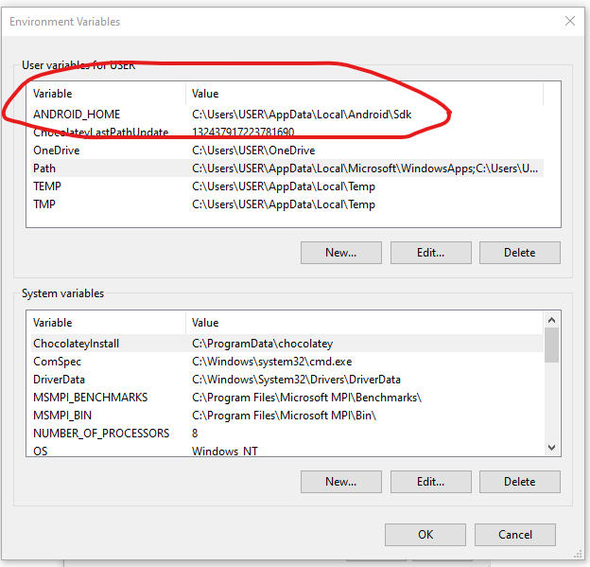

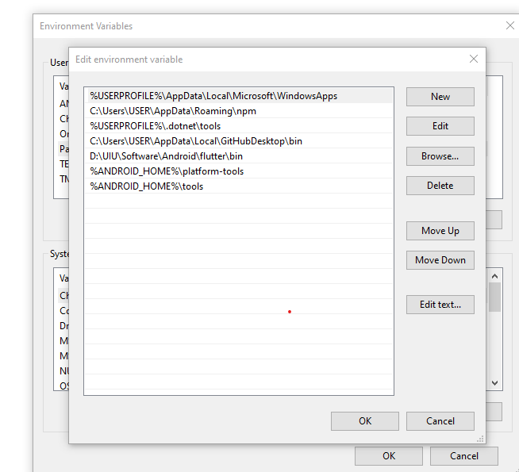

* To create a new project for flutter , we need to go to the desired folder (via cmd/explorer) and write command **flutter create projectname** . Important keep the new app to one word only, mean no space.
* The wizard will create the app for us. We can open the folder via android studio after that. For first time we need to install the **Dart and Flutter** plugins.
* Download the Google USB driver from avd manager-> tools for future use.
* We can run in cmd **flutter doctor** to see if anthing missing.